**Position**

***Static:*** By default

Not affected by top, right, bottom and left properties

***Fixed:*** Relative to the viewport, it means it will **always** stay in the same place even if the page is scrolled.

You can use the top, right, bottom and left properties.

***Relative:*** It’s positioned relative to the original position

***Absolute:*** Positioned relative to the ancestor

Moves along with the scrolling

***Overflow:*** Specifies whether to clip content or add scrollbars when the content of an element is too BIG to fit an specified area

***Visible:*** It renders outside the element’s box

***Hidden:*** The overflow is clipped and the rest of the content will be invisible

***Scroll:***  A scrollbar is added to see the rest of the content

***Auto:*** A scrollbar should be added to see the rest of the content

**Float:** Property specifies whether or not an element should float

**Clear:** Used to control the behavior of the float elements.

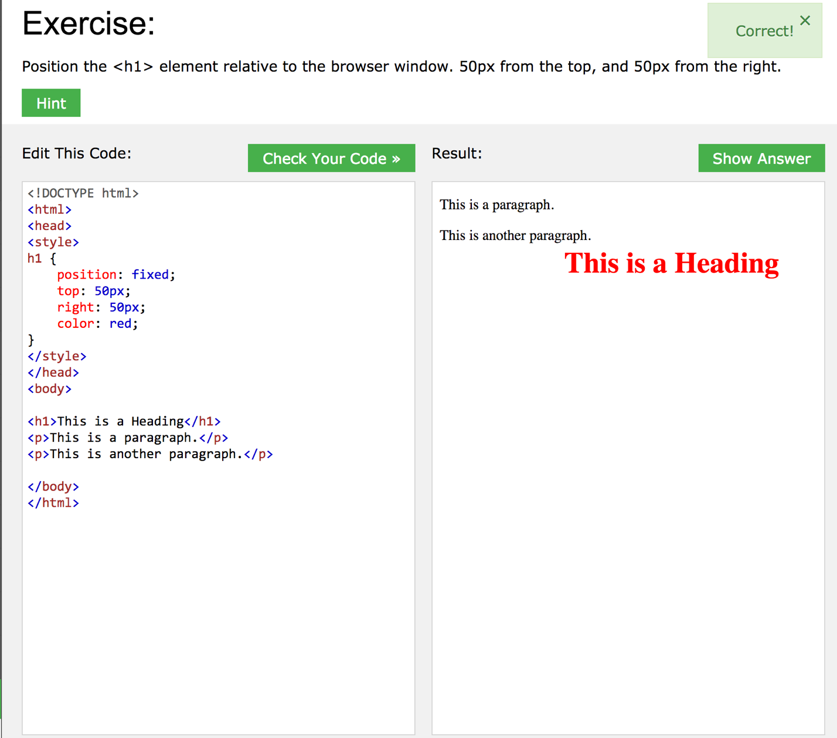CSS layout exercises

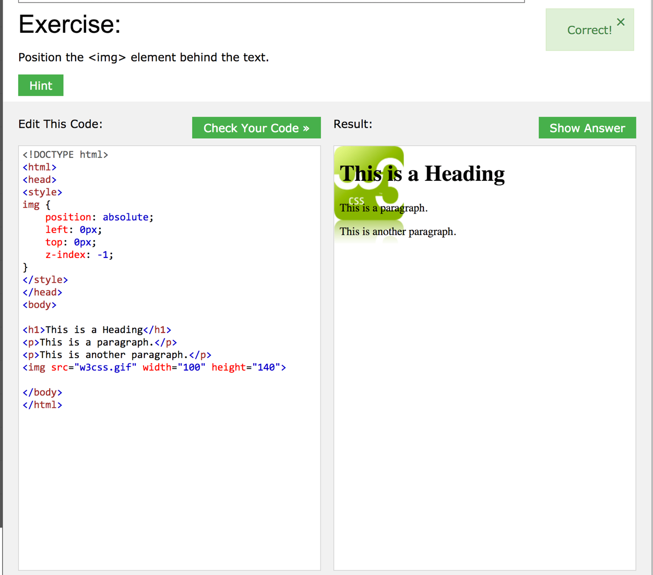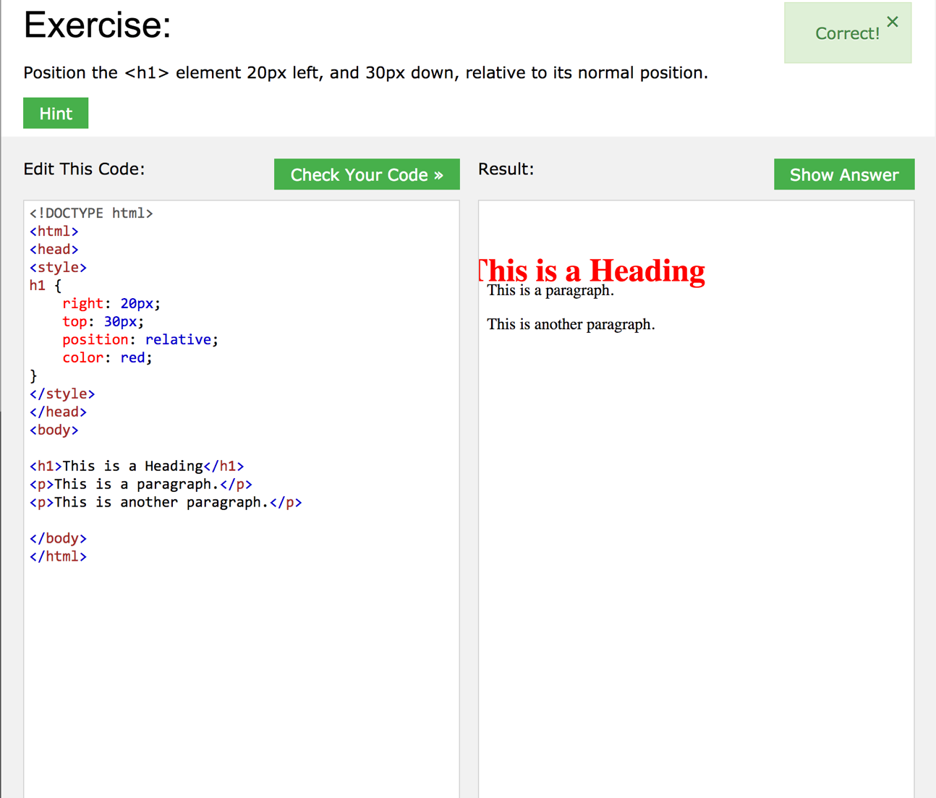

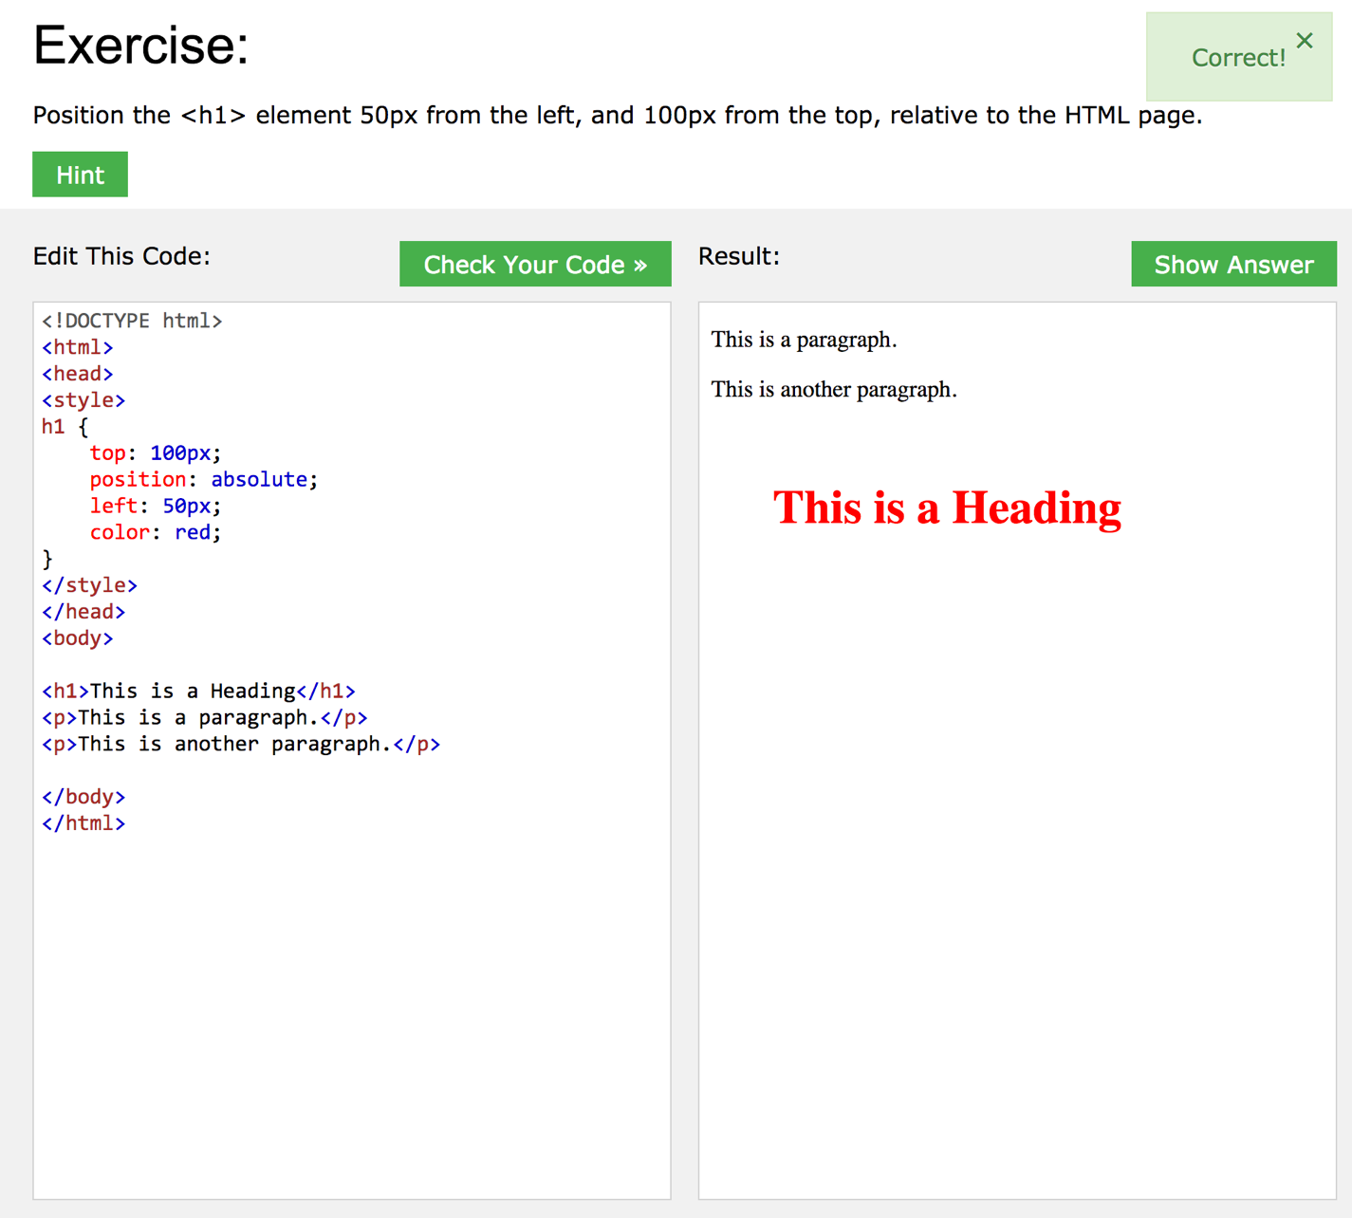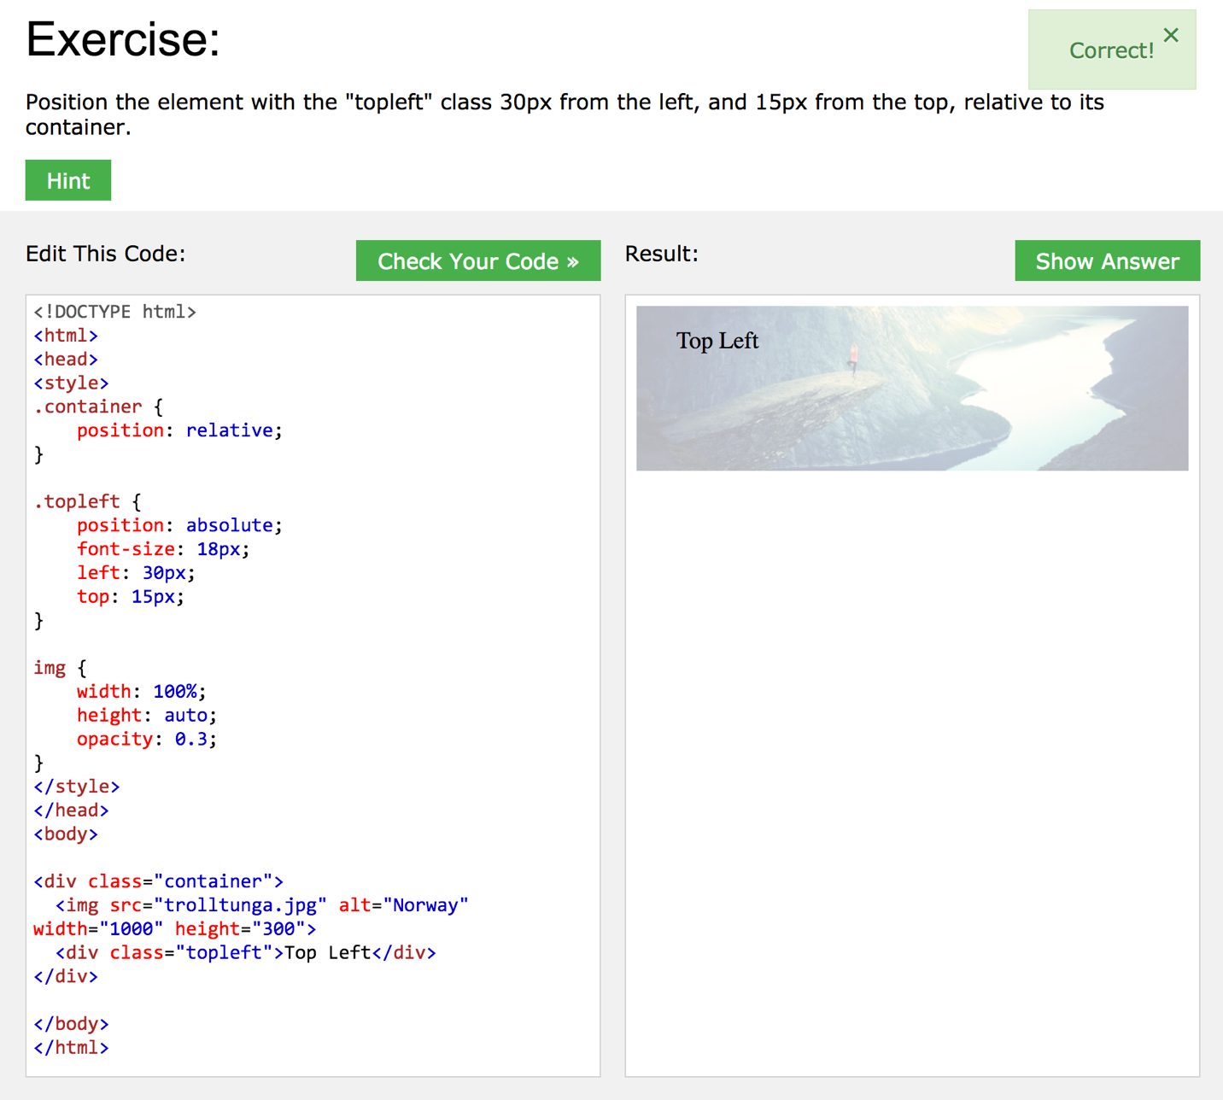

CSS LAB image

